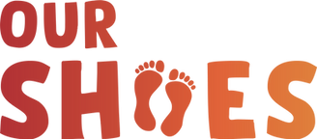

Suggested email to send to your parents:
We need your shoes!
We are delighted to be taking part in this year’s Our Shoes campaign, collecting pre-loved sports shoes and sending them to children in African townships.
Watch this video to learn more about the Our Shoes: https://www.youtube.com/watch?v=sclgs57EsVU&t=97s
We need:
- Used but in good condition children’s sports shoes (runners, sneakers, football boots etc)
- Just ask yourself would you be happy for your child to still wear them, if the hadn’t been outgrown.
- Clean shoes - they need to be reasonably clean i.e. no obvious dirt or muck, check the soles
- Shoes need to be tied together securely via the laces, with cable ties or strong elastic bands.
So get up into the attics and under the stairs now!
See https://www.ourshoes.ie/parents for more information on the campaign and the impact in makes in Southern Africa.

